Tutorial 2
Tasks:
- Modify the MLP model to have different numbers of hidden layers and neurons
  - How does increasing the number of layers or neurons affect the accuracy and learning curve?
Increasing the number of neurons makes the loss decrease more sharply (shown in c) compared. While increasing the number of layers (while keeping the number of neurons the same).The loss value reaches 0.2 at around 220 epochs. In the original, it reached a value of 0.2 at around 250 epochs. Thus, the model improves slightly with an increased in the number of neurons. As for Accuracy, it remains the same across all three cases.

    - With 2 Hidden Layer and 10 neurons each (Original Parameters)
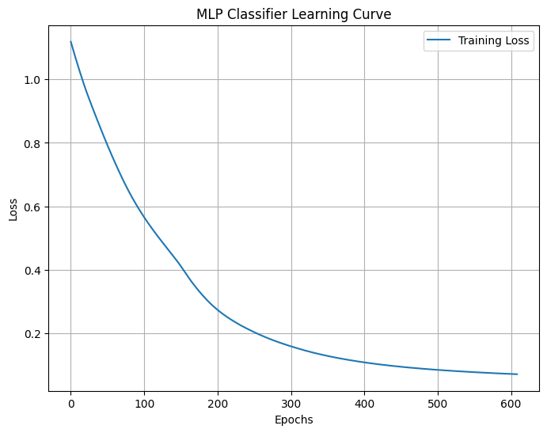

Accuracy=1.0

    - Increasing number of layers to 3 (10,10,10 neurons)
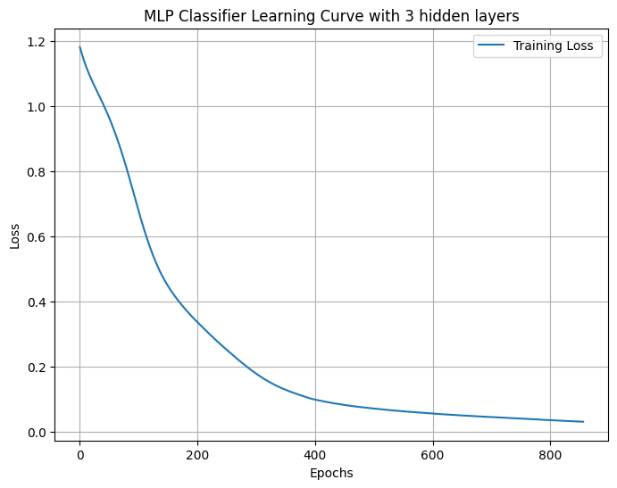

Accuracy=1.0

    - Increasing the number of neurons to 20 ( 2 layers only)
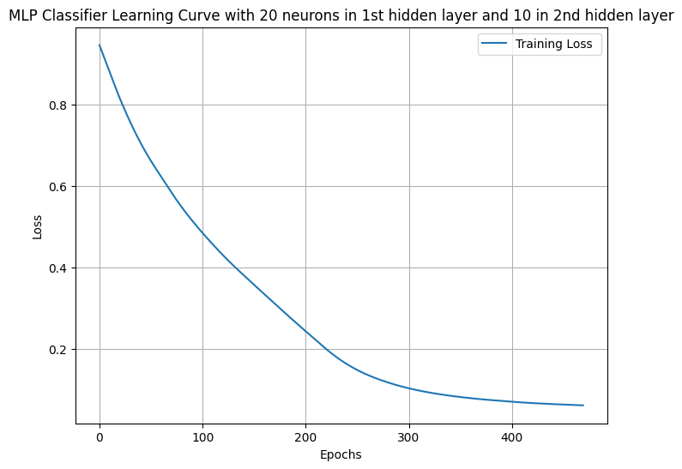

Accuracy=1.0

What configuration gives the best performance?

Increasing the number of neurons gives the best performance compared to increasing just the number of layers as the loss decreases more sharply.

- Change the learning rate of the MLP model and observe its effect on convergence.
  - Train the model and plot the learning curve.
How does changing the learning rate affect the loss curve and the number of epochs?
- Learning Rate =0.001 | - Learning Rate=0.1
Accuracy= 1.0 | 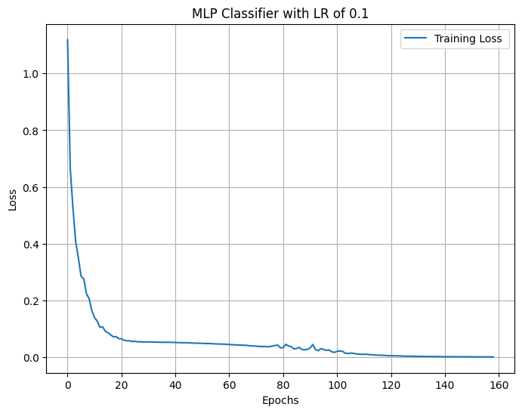  Accuracy: 0.96
- Learning Rate =0.0001 | - Learning Rate=0.0005
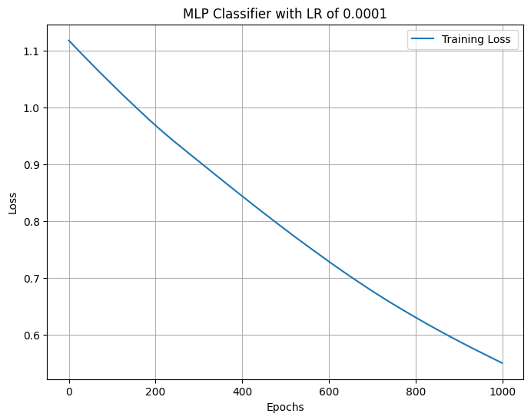  Accuracy: 0.73 | 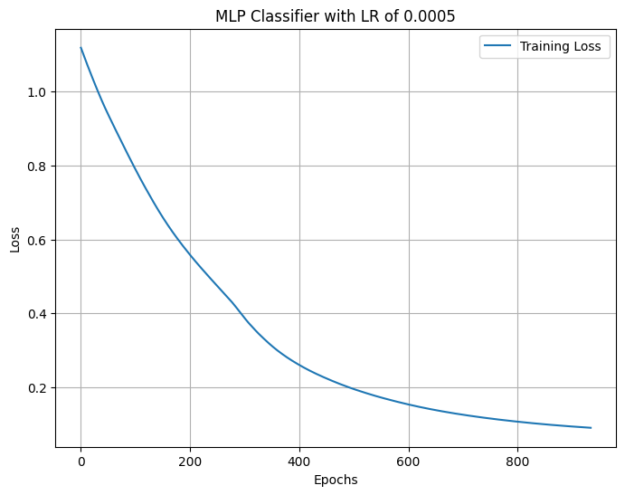  Accuracy= 1.0

Increasing the learning rate to 0.1 (shown in (b)) decreases the accuracy. However, the loss curve decreases more sharply. It reaches a value of 0.2 loss at 10 epochs whereas with a smaller learning rate it takes around 250 epochs to reach the same value. With a smaller learning rate such as 0.0001, it has a lower accuracy of 0.73 and the training takes longer to converge. This explains why the loss curve is different than the rest and looks almost linear.

